COVID-19 Resources: Early Childhood & Disability Inclusion
Compiled on 19th March
- Asia-Pacific Regional Network for Early Childhood (ARNEC) (compiled resources)
https://arnec.net/ecd-resources
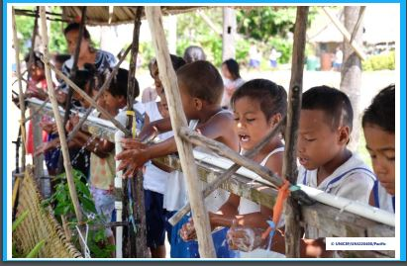
Key Messages and Actions for COVID-19 Prevention and Control in Schools - March 2020
by WHO, UNICEF, IFRC
Click here for a copy of the guidance

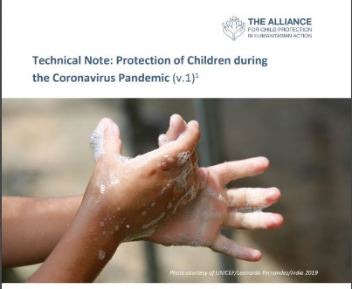
Technical Note: Protection of Children during the COVID-19 Pandemic
by The Alliance for Child Protection in Humanitarian Action
Click here for a copy of the guidance note

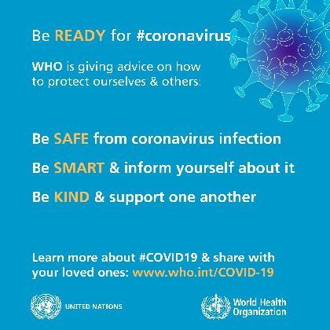
WHO advice for the public
by WHO
Click here to access the advisory and other useful resources (posters and videos)

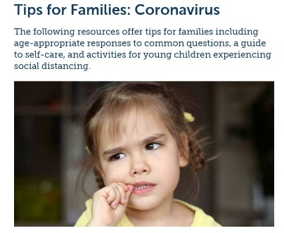
Tips for Families : Coronavirus
by Zero to Three
Click here for more parenting resources which offer tips for families to cope with COVID-19, including age-appropriate responses to common questions, a guide to self-care, and activities for young children experiencing social distancing.

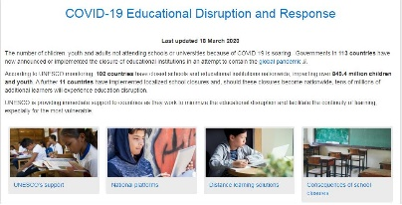
COVID-19 Educational Disruption and Response
by UNESCO
Click here for more information and resources by UNESCO to minimize the educational disruption and facilitate the continuity of learning.

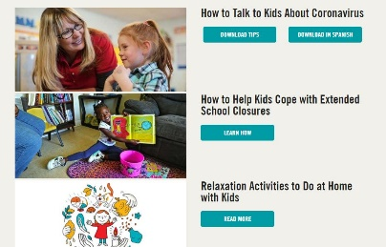
Coronavirus and Kids: Resources from Save the Children
by Save the Children
Click here for tools and tips for parents, caregivers and teachers

- Healthy Newborn Network
https://www.healthynewbornnetwork.org/resource/covid19-interim-guidance-who/
- Massachusetts Association for Infant Mental Health
https://massaimh.org/member-resources/covid-19-resources/
- Talking to Children about COVID-19-
https://hawthornefamilyplayschool.org/2020/03/12/talking-to-your-child-about-coronavius-in-ways-that-ease-their-fears/?fbclid=IwAR0zw4PFtDbuWiRdaNmPT6O47ECMFfxrGLtusYtiZ_neggWC94be31rDLSg
- Social Norms Story (handwashing, etc) for Children-
https://8cd9982f-d094-4892-a91c-91cb99ad69ce.filesusr.com/ugd/10ff36_d1e7575fc6214d01bad1cd0cd8921418.pdf
- Early Learning-
https://earlyedgecalifornia.org/coronavirus-resources-for-the-early-learning-community-in-california/
- Intellectual Disabilities-
This easy to read booklet about the Coronavirus is from SARTAC. It is in English and Spanish. It was written by and for people with intellectual and developmental disabilities (IDD). It focuses on “need to know” information (not “nice to know” information). Please share it widely. I have also attached the PDF versions to this email.
Plain Language Booklet on Coronavirus
https://selfadvocacyinfo.org/wp-content/uploads/2020/03/Plain-Language-Information-on-Coronavirus.pdf

Spanish Plain Language Booklet on Coronavirus
https://selfadvocacyinfo.org/resource/plain-language-information-on-covid-19-spanish-version/

SARTAC is the Self Advocacy Resource and Technical Assistance Center: https://selfadvocacyinfo.org/. This booklet was created by Green Mountain Self-Advocates, a SARTAC partner.

- Disability Inclusion Repository-
https://docs.google.com/document/d/1IVP1u6yHfLuN9qNyLEct5-vtC0aqLKtKr-o-faAjves/edit

